

Project Charter

Van Lang Admissions

# Revision Table

|  |  |  |  |
| --- | --- | --- | --- |
| **Author** | **Date** | **Reason for changes** | **Version** |
| Minh Đoàn | 14/10/2016 | Initial Document | 1.0 |
| Xuân Thái Hiền, Minh Đoàn | 14/10/2016 | Update data | 1.1 |
| Minh Đoàn | 23/10/2016 | Update data and template | 1.2 |
| Tài Nguyễn | 26/5/2017 | Update Project Charter | 2.0 |
| Khoi Nguyen | 29/5/2017 | Fix template | 2.1 |

Contents

Revision Table 1

1. Application background 4

2. Project Purpose 4

2.1 Business Case 4

2.2 BUSINESS OBJECTIVE 4

3. Project description 5

4. Implementation Time 5

5. Key Stakeholders 6

6. Milestone 6

7. Constraints, Assumptions, Risks and Dependencies 6

Document Approvals

The following signatures are required for approval of the document

1. On the behalf of Van Lang University

Date: 14/10/2016

Đặng Thế Quang

1. On the behalf of Development Team

Date: 14/10/2016

Trần Xuân Hải

Date: 14/10/2016

Nguyễn Hoàng Anh Tài

Date: 14/10/2016

Đoàn Anh Minh

Date: 14/10/2016

Nguyễn Thái Hiền

Date: 14/10/2016

Nguyễn Anh Khởi

# Application background

Van Lang University is a non-public university, founded in 1995. Today, the school has 11,000 students enrolled. Every year, the recruitment of 3,000 new students enrolled. So support systems that promote enrollment, and enrollment management is always an important priority.

# Project Purpose

## 2.1 Business Case

* Van Lang Admissions is a solution built with the most appropriate requirements set out in order to introduce and give more information for every student, which they want apply to van lang.
* Van Lang Admissions is created to attractive more and more student apply to Van Lang University.

## 2.2 BUSINESS OBJECTIVE

* The business objective of this project is a solution to update and manage information easy, it helps system change news, banner and manage or answer question easily.
* Complete implementation the new Van Lang Admission website within the next 30 weeks.

# Project description

* Nowadays, apply information technology into admission of university is very important and necessary. Specially in technology age, mobile devices become general and most of sudent and family have mobile devices connect internet.
* With changeable in admission and require from Ministry of Education and Training that information relate in admission progress must annouce and public on university’s website. And all application support register examination and check result exam.System will have:
* Frontend:
  + Look up information about admissioin, FAQ.
  + See filing list, elect to university.
  + Register aptitude test.
  + See result aptitude test.
  + See and comment video admission.
* Backend:
  + Manage user and authorize for FAQ function.
  + Manage content FAQ: see, answer for candidate, post to website.
  + Manage content announce to candidate.
  + Import,export information admission: export aptitude list and candidate’s image, send profile data
  + Manage video content and comment admission consultants.
  + Manage popups, banners.

# implementation time

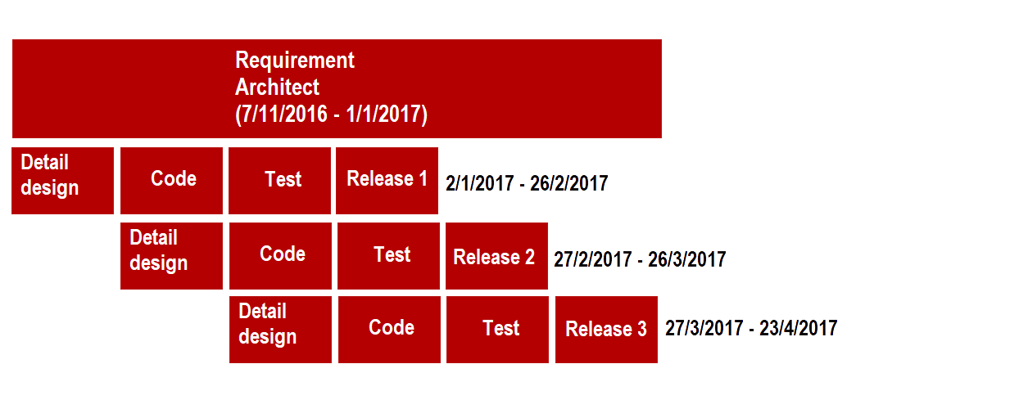

# KeyStakeholders

|  |  |
| --- | --- |
| **Customer** | Nguyễn Thế Quang |
| **Mentor** | Vũ Thế Nam |
| **Project Manager** | Nguyễn Thái Hiền |
| **Project Team Member** | Trần Xuân Hải, Nguyễn Hoàng Anh Tài, Nguyễn Anh Khởi, Đoàn Anh Minh, Nguyễn Xuân Thái Hiền |

# milestone



# Constraints, Assumptions, Risks and Dependencies

|  |  |
| --- | --- |
| Constraints | 1. Project lasted 30 weeks.  2. Project requires using AngularJS, NodeJS and MongoDB |
| Assumptions | 1. Everyone have a smart phone and Internet.  2. 3,000 new students enrolled every year. |
| Risks and Dependencies | 1. Using new technology. |